SIMATS ENGINEERING (SAVEETHA SCHOOL OF ENGINEERING)
Department of Artificial Intelligence and Data Science
ASSESSMENT TOOL 3 – CODING CHALLENGE

Course Code: | DSA03 | Course Title: | Natural Language Processing
CO Assessed: | CO1 – Imitation (L1) | Assessment: | Assessment Tool 3 – Coding Challenge
Weightage: | 30% of CIA
CO5 Statement: | Analyse NLP models, regular expression patterns, finite state automata, morphological processing techniques and to interpret language processing. (BL-3)
Student Name: | Y. Sai kumar | Reg. No.: | 192425218
Section / Batch: | 2024 Btech- AIML | Date:

Code of Conduct
I Y. Sai kumar (Name / Reg No) certify that this submission is my original work and that I have adhered to the guidelines specified for this assessment. I understand that any violation of academic integrity rules will result in disciplinary action.
Signature of the Student: _________________________

Instructions
- Develop a complete and modular Python program that meets all the functional requirements specified in the coding challenge using appropriate algorithms, data structures, and programming practices.
- Test the program using multiple valid and invalid test cases, and clearly display the input, processing, and output to verify the correctness of the implementation.
- Follow standard coding practices by using meaningful variable names, proper indentation, comments, exception handling (where applicable), and upload the source code, sample outputs, and README file to the designated GitHub repository.
- Duration: 40 minutes.

Section / Topic | Focus | Q Nos
Porter Stemmer | class design, methods, encapsulation, and rule-based stemming | 1

Annexure A – Coding Challenge
Section 1: Object-Oriented Implementation of a Porter Stemmer
You have recently joined an NLP startup called LexiMind Technologies. The company is developing a search engine for a digital library containing millions of research papers. Users expect the search engine to return relevant results even when different grammatical forms of a word are used.
For example, a search for connect should also retrieve documents containing connected, connecting, connection, and connections. To achieve this, the development team has decided to implement the Porter Stemming Algorithm from scratch.
Since the algorithm consists of multiple sequential rules (Step 1a, Step 1b, Step 1c, Step 2, Step 3, Step 4, Step 5a, and Step 5b), the project manager has divided the work among team members. Each developer is responsible for implementing and testing one specific rule. At the end of the project, all modules must be integrated into a single, fully functional stemmer.
Assessment Task
Phase 1: Individual Task (Assigned Rule)
Each student will be assigned one Porter Stemmer rule.
Your responsibilities are to:
- Study and understand the assigned rule.
- Explain the linguistic purpose of the rule.
- Describe the conditions under which the rule should be applied.
- Implement the rule in Python.
- Prepare at least 10 test words demonstrating:
  - Words that satisfy the rule.
  - Words that should remain unchanged.
- Document the input, expected output, and actual output.
- Explain any limitations or special cases encountered.
CODE
def stem(word):
if word.endswith("iness"):
return word[:-5] + "y"
elif word.endswith("ness"):
return word[:-4]
elif word.endswith("ies"):
return word[:-2]
elif word.endswith("sses"):
return word[:-2]
elif word.endswith("s") and not word.endswith("ss"):
return word[:-1]
return word

x = input()
print(stem(x))
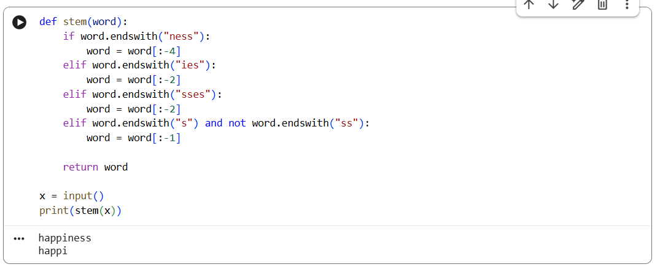
Phase 2: Team Integration
As a team, integrate all individual rule implementations into a complete Porter Stemmer.
The team must:
- Arrange the rules in the correct execution order.
- Resolve conflicts between rule implementations.
- Ensure that the output of one rule becomes the input to the next rule.
- Test the complete algorithm using at least 50 different English words.
- Compare the team's results with the NLTK Porter Stemmer.
- Identify and explain any differences.
CODE
x = input().lower()

if x.endswith("sses"):
x = x[:-2]
elif x.endswith("ies"):
x = x[:-2]
elif x.endswith("ss"):
x = x
elif x.endswith("s"):
x = x[:-1]

if x.endswith("eed"):
x = x[:-1]
elif x.endswith("ed") and any(c in x[:-2] for c in "aeiou"):
x = x[:-2]
elif x.endswith("ing") and any(c in x[:-3] for c in "aeiou"):
x = x[:-3]

if x.endswith("y") and any(c in x[:-1] for c in "aeiou"):
x = x[:-1] + "i"

if x.endswith("ness"):
x = x[:-4]
elif x.endswith("ful"):
x = x[:-3]
elif x.endswith("ical"):
x = x[:-4] + "ic"

if x.endswith("e") and len(x) > 2:
x = x[:-1]

if x.endswith("ll"):
x = x[:-1]

print(x)
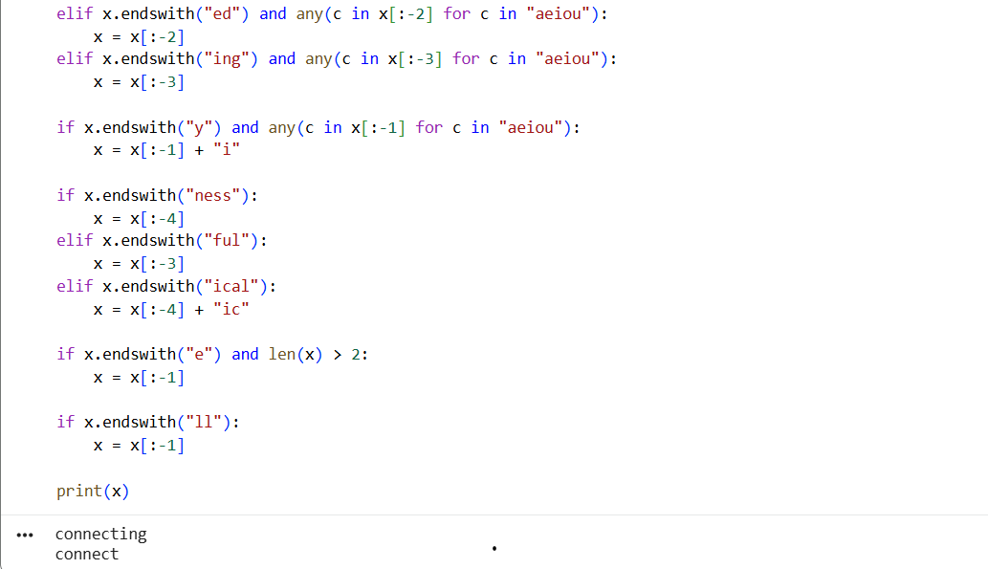
Phase 3: Reflection
Prepare a report addressing the following questions:
- Why is the order of Porter Stemmer rules important?
- What errors would occur if your assigned rule were skipped?
- How did integrating multiple rules improve stemming accuracy?
- Which rule was the most challenging to implement and why?
- What improvements would you suggest for the Porter Stemming algorithm?
CODE
x = input().lower()

if x.endswith("sses"):
x = x[:-2]
elif x.endswith("ies"):
x = x[:-2]
elif x.endswith("ss"):
x = x
elif x.endswith("s"):
x = x[:-1]

if x.endswith("eed"):
x = x[:-1]
elif x.endswith("ed"):
x = x[:-2]
elif x.endswith("ing"):
x = x[:-3]

if x.endswith("y"):
x = x[:-1] + "i"

if x.endswith("ness"):
x = x[:-4]
elif x.endswith("ful"):
x = x[:-3]
elif x.endswith("ical"):
x = x[:-4] + "ic"

if x.endswith("e") and len(x) > 2:
x = x[:-1]

if x.endswith("ll"):
x = x[:-1]

print(x)
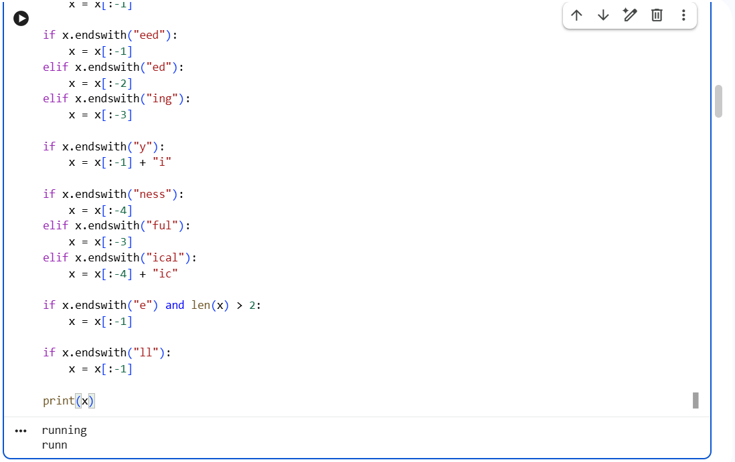

Rubrics for Calculation
Criteria | Weightage | Level 4 – Exemplary | Level 3 – Proficient | Level 2 – Developing | Level 1 – Beginning
Problem Understanding | 20% | Clearly understands problem constraints, edge cases, and competitive requirements | Understands problem with minor gaps in constraints | Partial understanding; misses key constraints | Misinterprets problem or constraints
Algorithm | 25% | Selects optimal algorithm with best time and space complexity for competitive constraints | Uses efficient algorithm with minor scope for improvement | Uses basic/inefficient approach | No clear algorithmic approach
Code Implementation | 20% | Writes correct, efficient, and clean code that passes all constraints | Code works with minor errors or inefficiencies | Partially correct code; fails for some cases | Code does not execute or gives incorrect results
Competitive Performance | 20% | Solves problem within time limits and handles large inputs effectively | Solves within acceptable time with minor delays | Struggles with time limits or larger inputs | Unable to solve within time constraints
Test Case Handling | 15% | Handles all test cases including edge and hidden cases | Handles most test cases | Misses important edge cases | Fails on multiple test cases

Q. No. / Criteria | Problem Understanding | Algorithm | Code Implementation | Competitive Performance | Test Case Handling | Sub. Total | Total %
1
2
3

Faculty In-charge | Course Coordinator | Program Director
Dr.T.Kumaragurubaran
Signature: _______________ | Signature: _______________ | Signature: _______________
Date: ___________________ | Date: ___________________ | Date: ___________________

